**NAME**: **Caroline Nyambura Wachira**

**Email**: [Caroline.nyambura@womentechsters.org](mailto:Caroline.nyambura@womentechsters.org)

**Date of submission: Friday 28th May 202**

**PRACTICAL ASSIGNMENT**

**QUESTION 1**

Deploy a windows server 2016 Gen 1 remotely on our machine from Azure Cloud.

**ANSWER**

**STEPS**

**NB; The photos below are in line with the procedure below**

1. Sign into your Microsoft Azure Account
2. Click on virtual machine to create a new one
3. It will direct you to the creation page

4.Under instance details give your virtual machine name

5.Select region closer to you

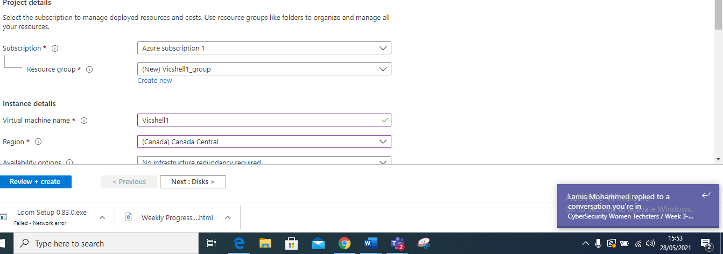

6. Select images which is windows sever 2016 Gen 1

7. Under administration account put your username and password

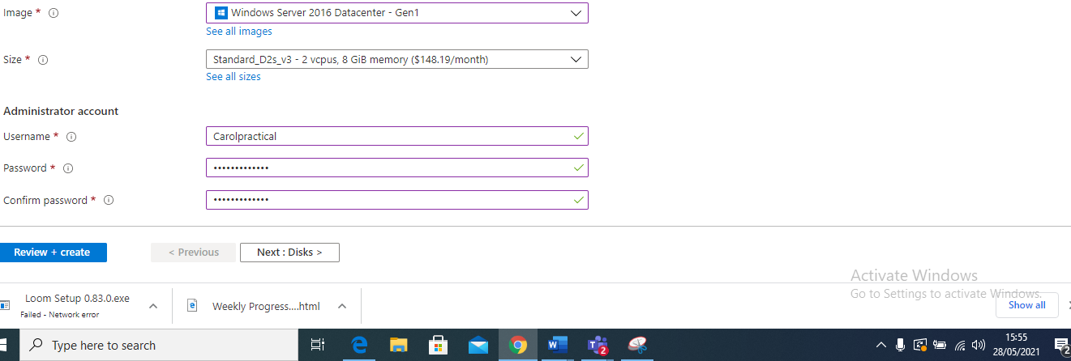

8.Under inbounds ports select the ports that you want to use HTTP(80), RDP (3389) and SSH

9. Click on next disk, next networking, next management, next advanced, next tags

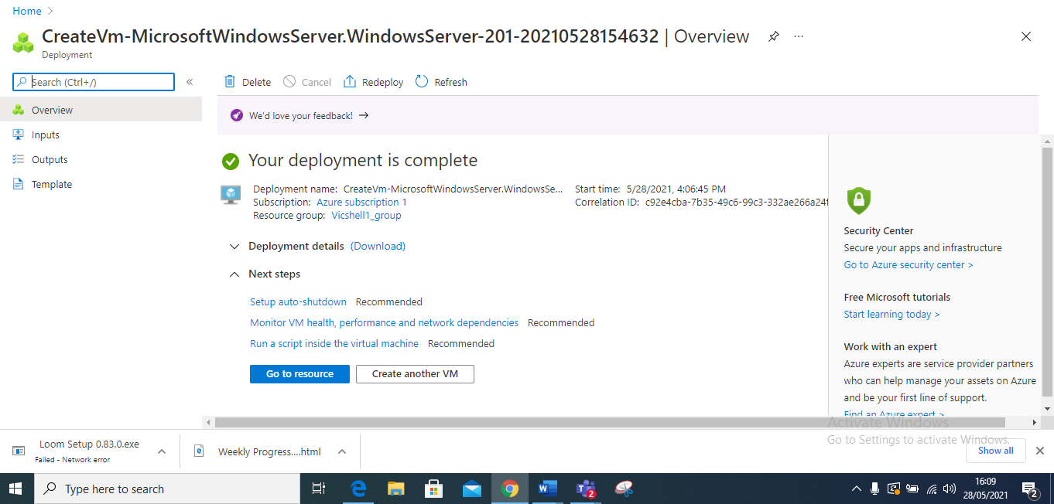

10. Click on review and create

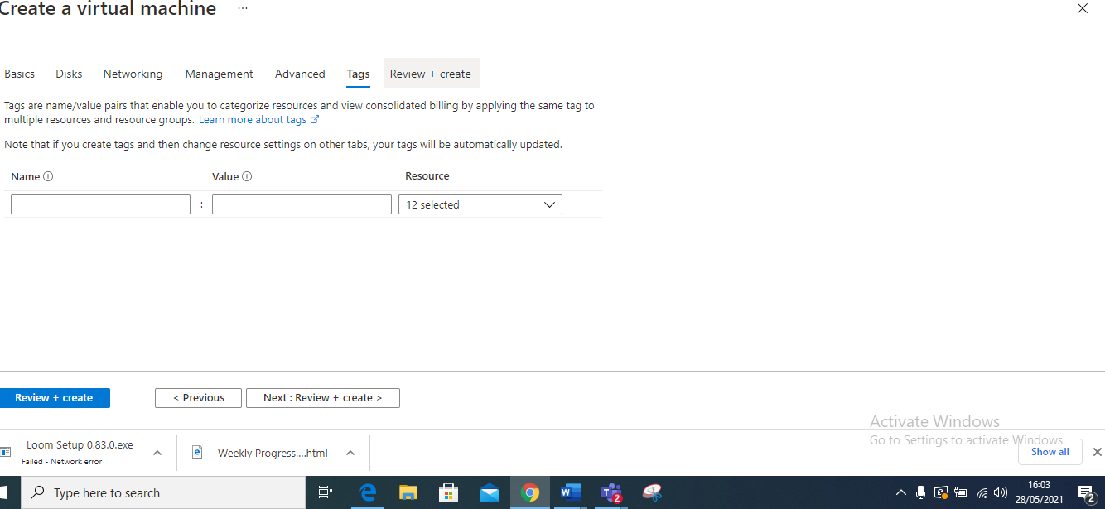

11. Click on create and once it has created click on go to resources

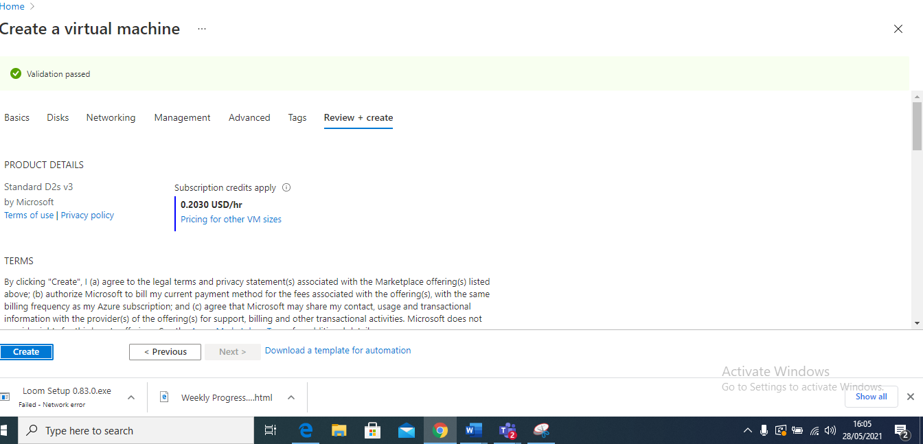

**Question 2**

Install the windows feature web management tool and confirm from your browser

1. Once you have created your virtual machine, click on connect and then on the RDP.

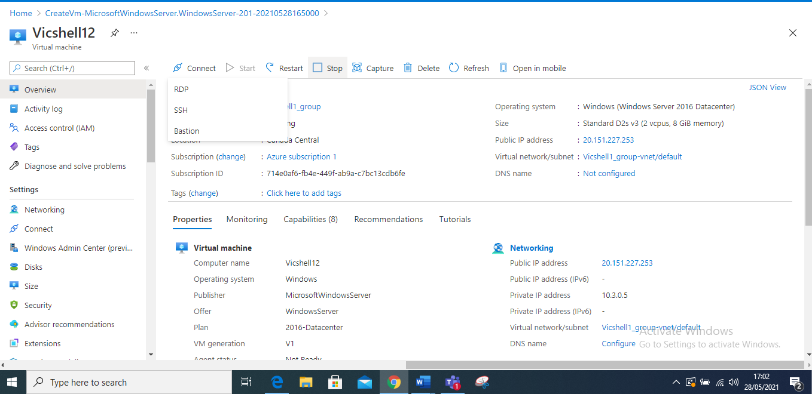

1. Click on the highlighted download RDP file.

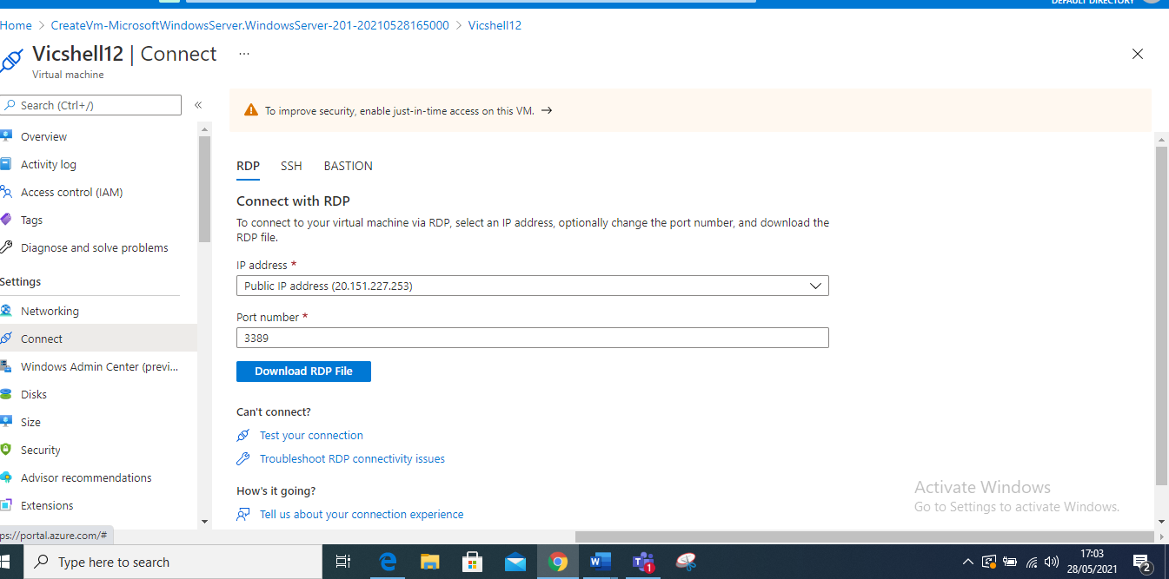

2.Once you have downloaded the file you can open it and connect

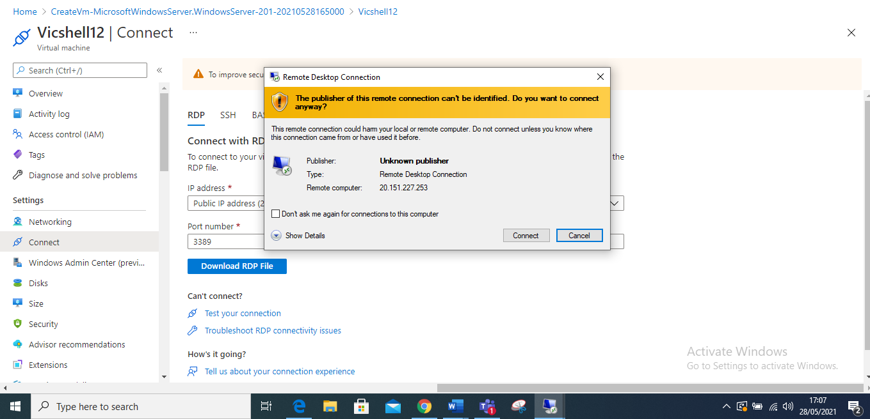

3.Fill in your credentials

4. and click Yes to verify

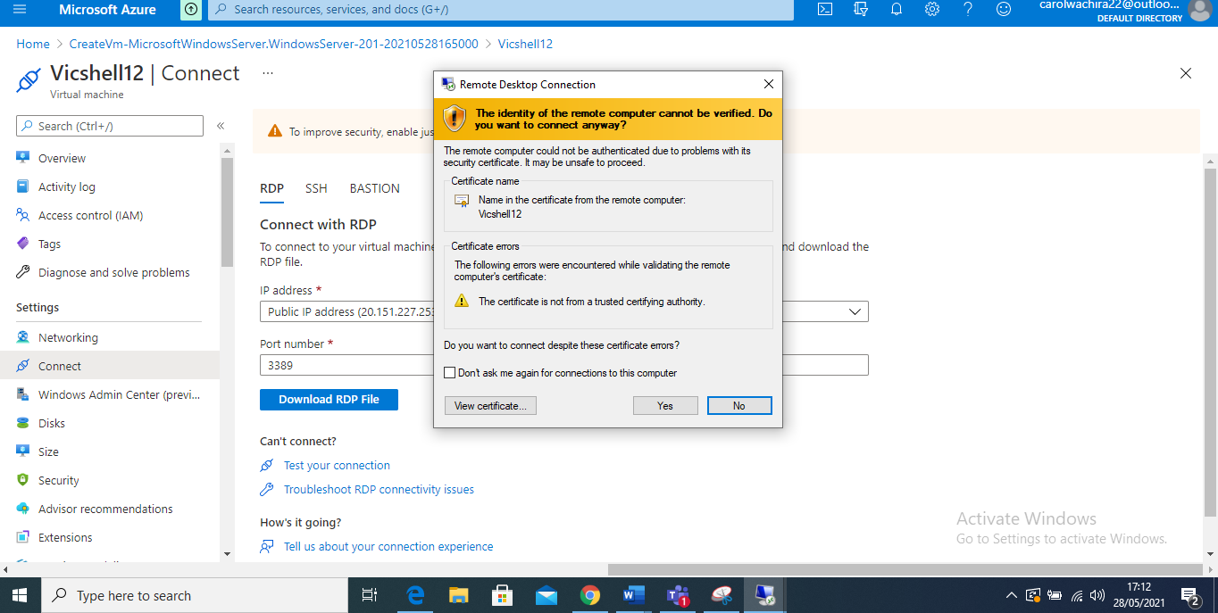

5. install a feature in the PowerShell, by clicking on the cloud shell a small box next to the search box in Microsoft azure at the top, and change from bash to PowerShell then add the command “install-Windowsfeature -name Web-Server -includemanagementtools.”

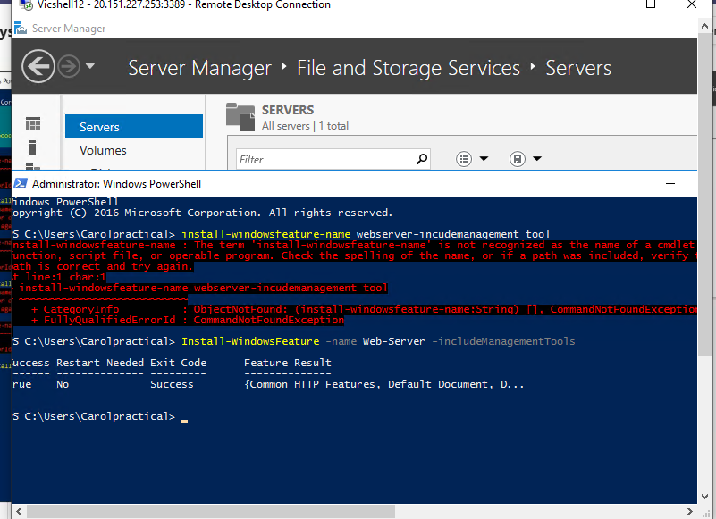

**Question 3**

Create a site recovery vault and add a site recovery to the replicated items in the site recovery vault

**Answer**

**STEPS**

1. Open your Microsoft azure account
2. You can use your already created virtual machine if you have , but if you don’t have you can create a new virtual machine, personally I will use vicshell12 virtual machine which I just created above
3. Search recovery service vault on the search box or click it direct from the dashboard

4 Click on add , new

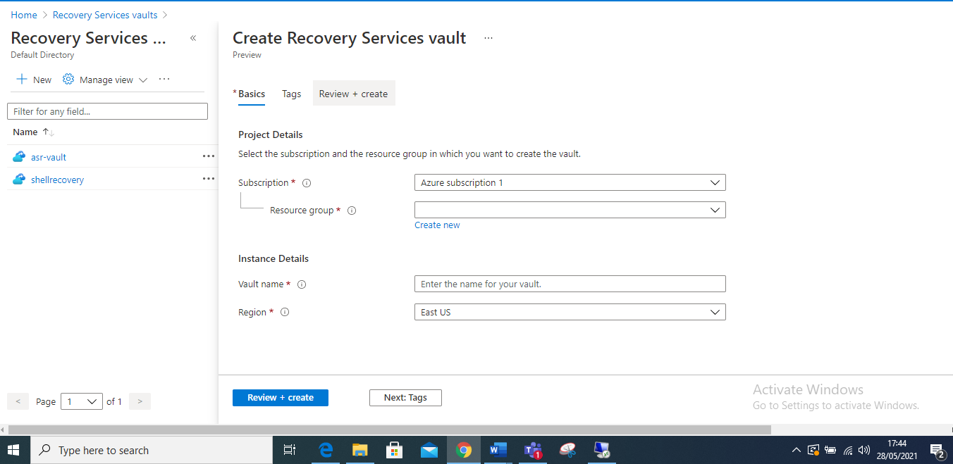

1. Click on resource group and give it a name

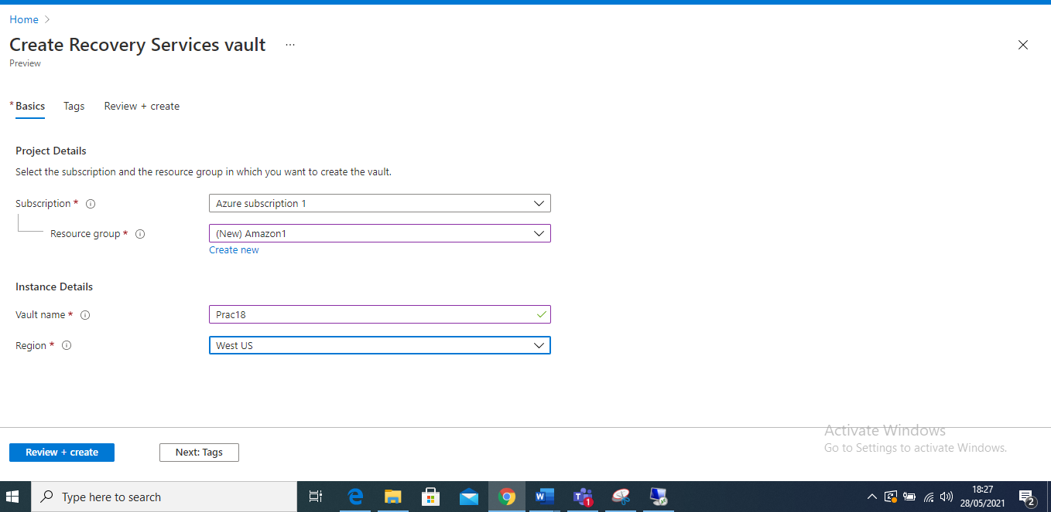

1. Click next on tags, hence nothing will change then click on review and create

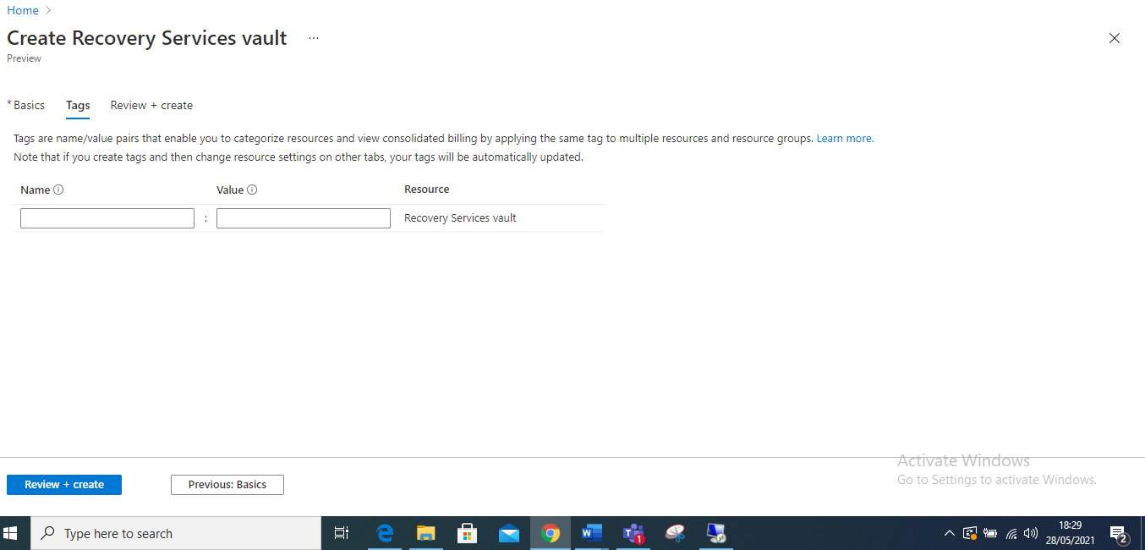

1. Click on create, once it has finished the deployment click on go to resources

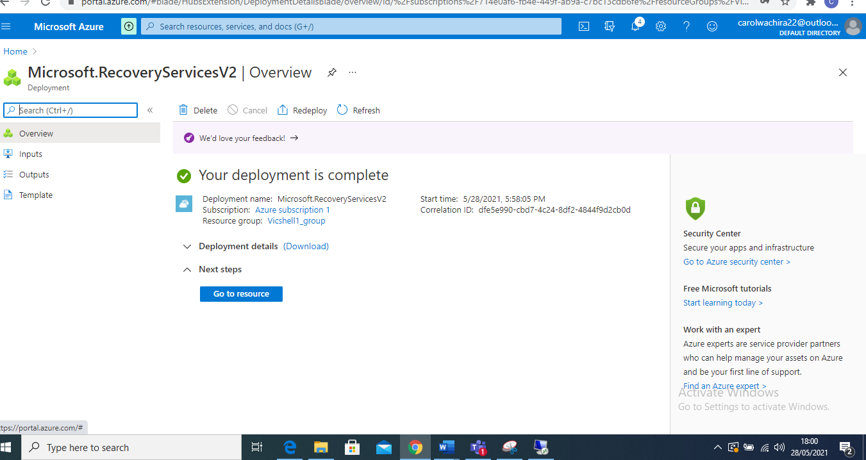

7.Go to protected items , on the overview and click on replicated items

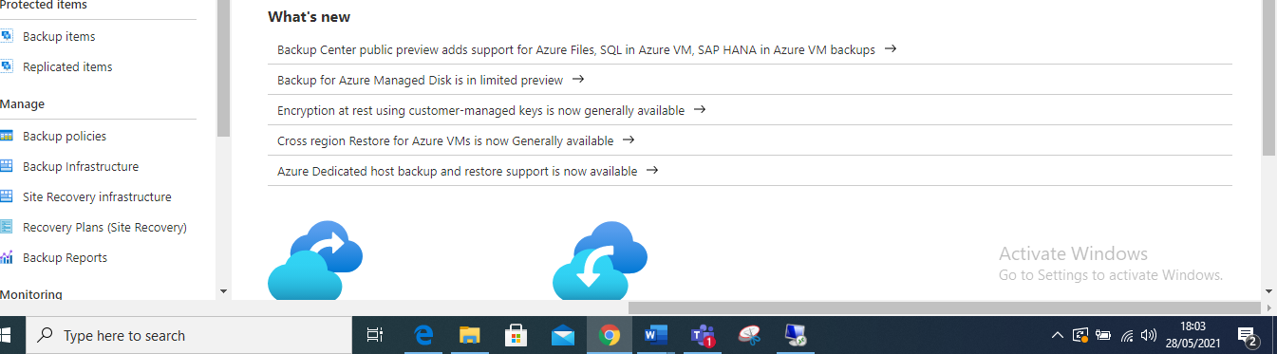

1. Once finished click on the top most part written replicate and from the drop-down menu choose azure virtual machines

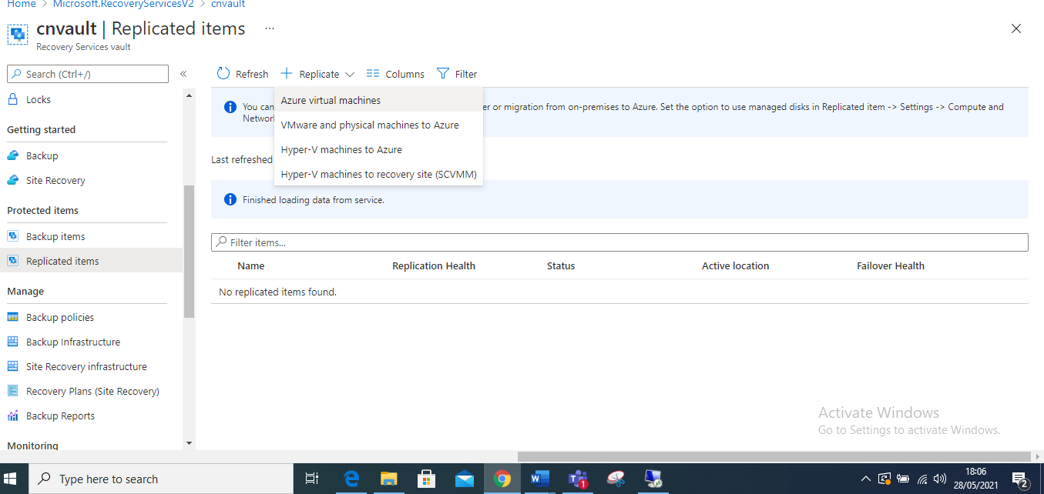

1. Fill in the source enable replication, from location to resource group and click next

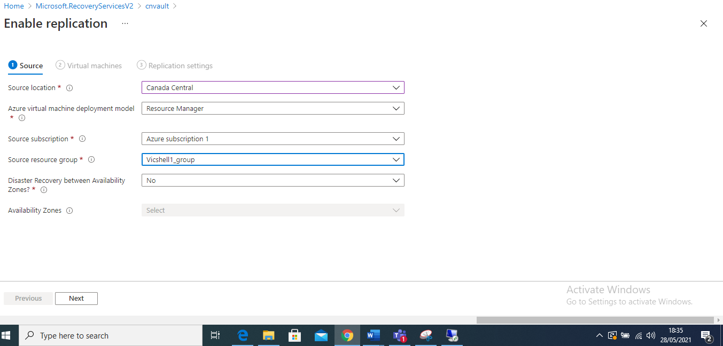

1. Click on the virtual machine and click next

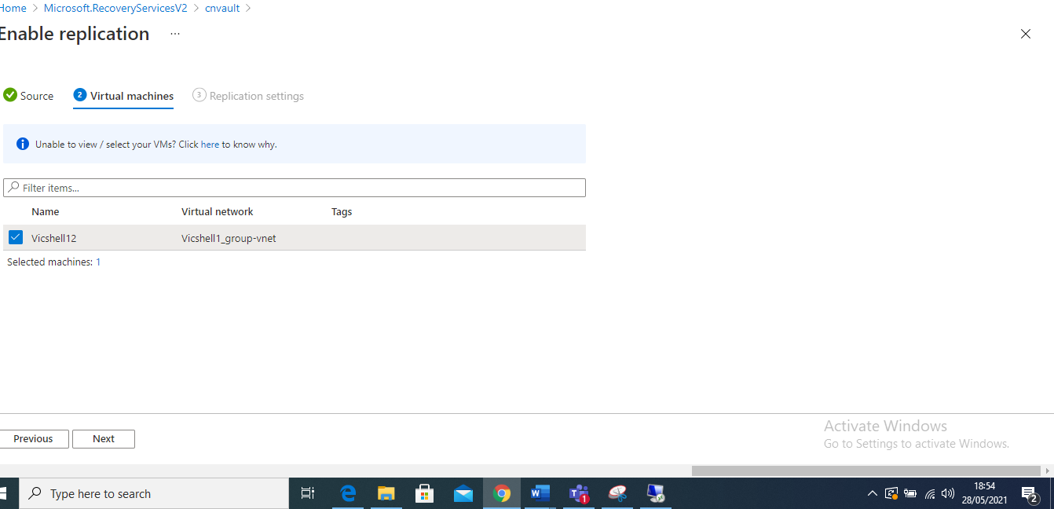

1. Ensure target location is correct, click on customized storage settings and check

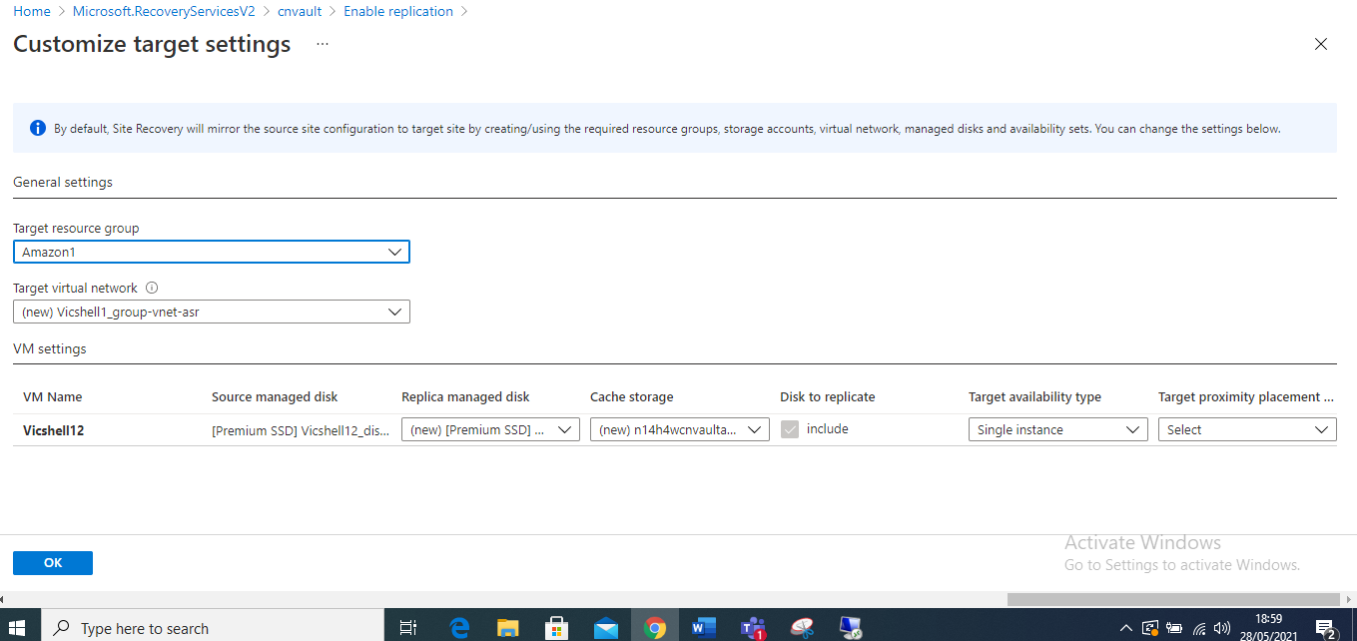

11 . Click on replicate and wait for it to finish

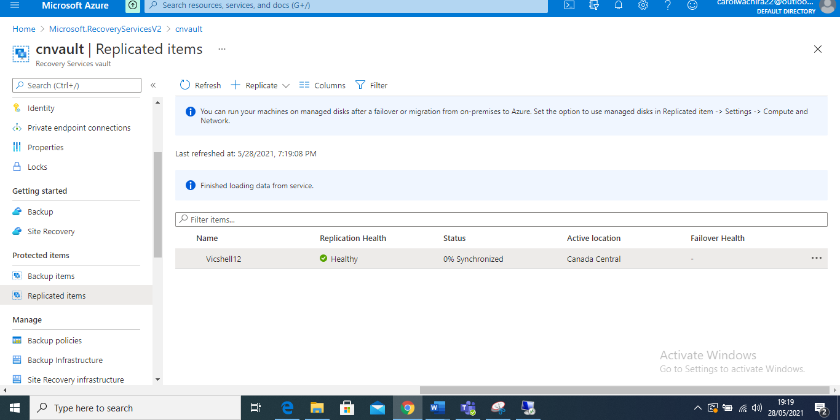

12.Wait until status is protected

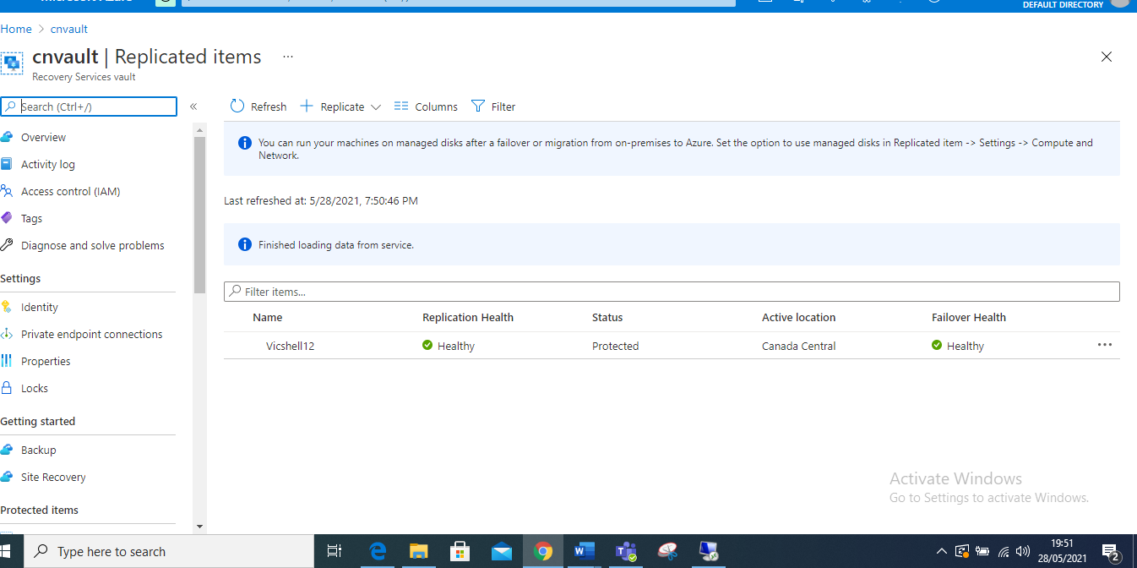

13.Once its selected go home page select the virtual machine that you replicated go to overview and in operations select disaster recovery

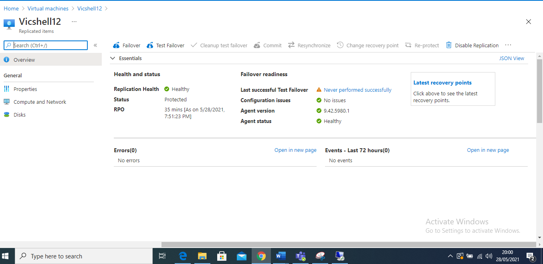

**Question 4 and 5**

Stops the window server from azure to assume its breakdown and perform a test failover for the window server

**Answer**

1. To view the replication details from the overview select essentials and click on test failover

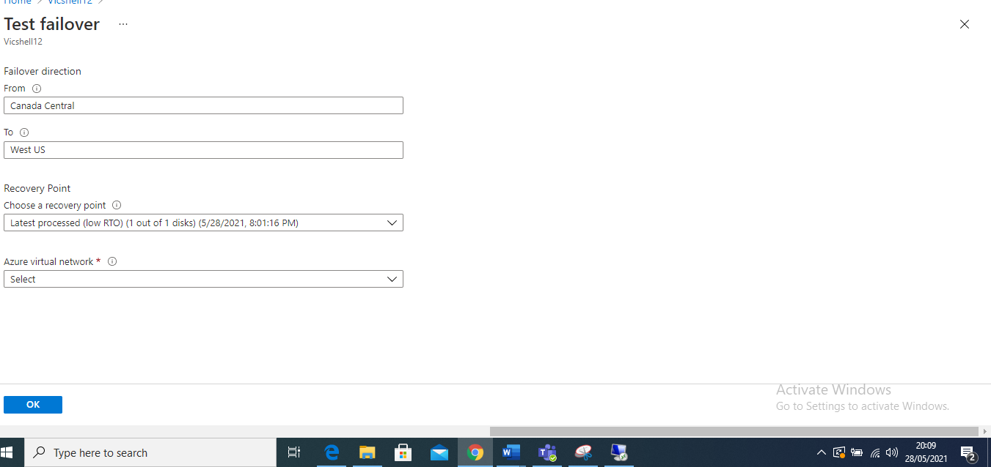

1. You can now perform a test failover and view it

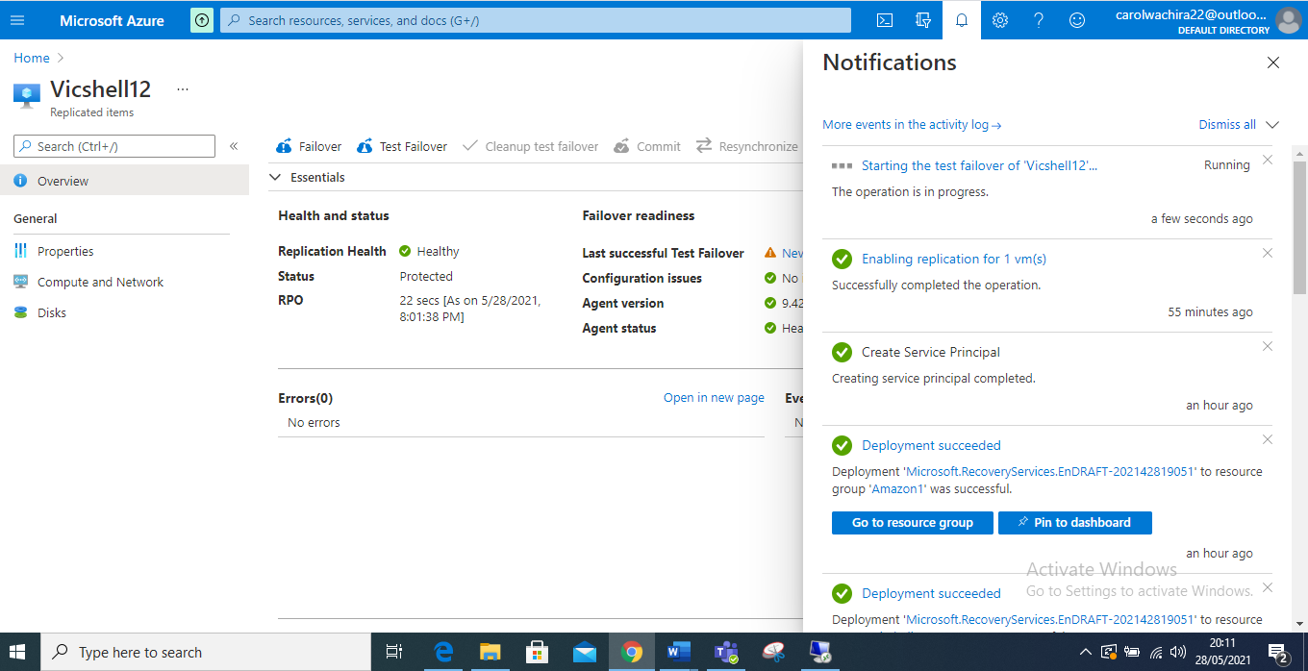

1. Once the test failure is completed you can go back to the virtual machines and see the test failure machines

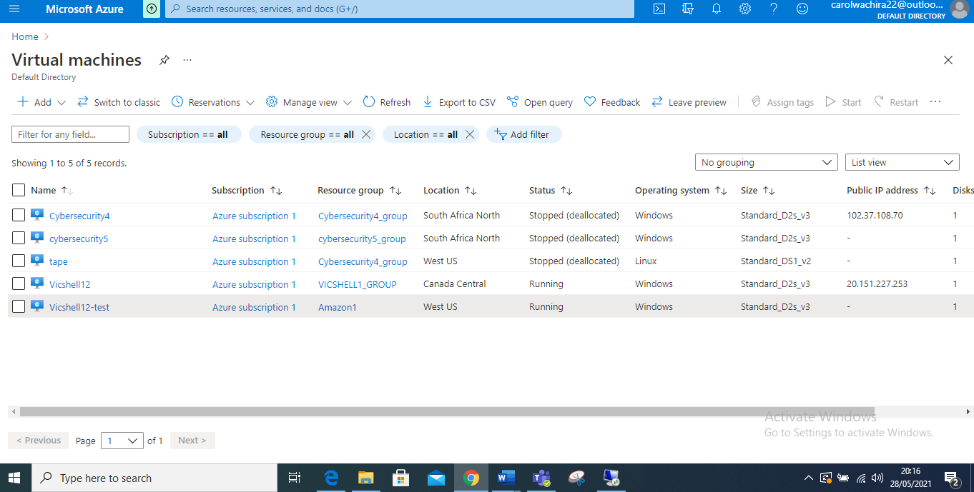

1. One is able to view the test virtual machine hence the virtual machine is running , that shows the disaster recovery for the vm is okay, one can now go back to the disaster recovery and window and clean up the resource.